**Final Project Report File**

**Sunshine Institute**

**Harman Kaur**



**Project Overview**

Purpose

For the purpose of expanding business and to make online business of Sunshine Institute and saving details of staff and other important details for the easy usability that defiantly help this institute to grow more.

Goals

To increase the customer through online medium goal is to create a website that can give information about the Sunshine Institute . Engage more Students for joining .

Moreover, next focus is that it should store all the information of students and course and staff and many things like this

Features

* **User Friendly**: The website would be responsive so that user can view the website easily on any platform either on mobile or on laptop
* **Eye Catching**: With the use of beautiful graphics the website is eye catching so that it shown as great work for portfolio as it is.
* **Gallery:** Students and class works pictures are uploaded here
* **Contact Form**: People can contact through contact us page regarding any queries.

**Target audience**

Teenagers who are ready to get knowledge of computer are targeted more because only interested candidates join these courses for the betterment of their skills that will help the people starting up their career

**Role of Admin**

|  |
| --- |
| Add Courses |
| Add Students |
| Register Staff Member |
| Fee Payment |
| View Queries |

**Accessing the Admin Panel**

By clicking on the SunShine Institute Logo page will redirect to the admin Panel where admin needs to enter the confidential details provided and can access to all the roles

**Screenshot for the Admin Login**

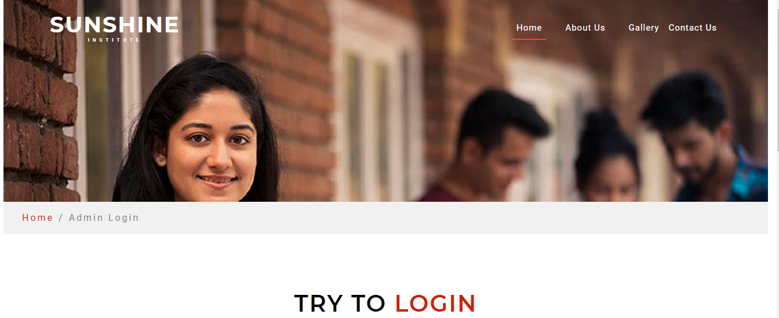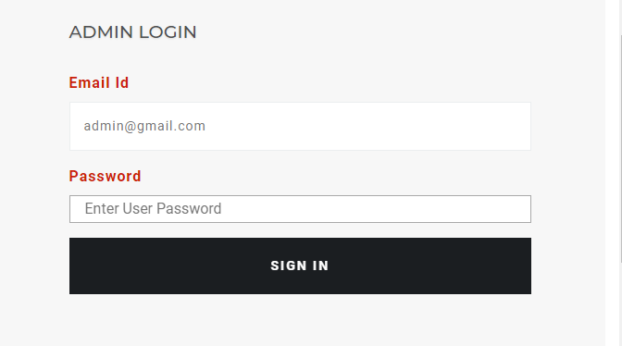

**After Logging In Accessing Admin Roles**

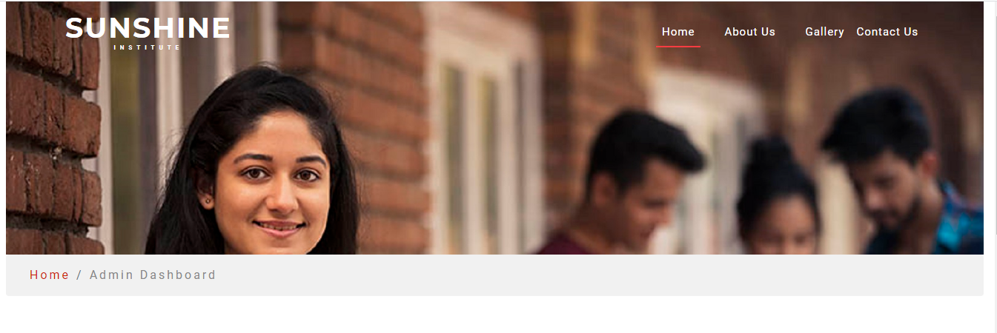



**Add Courses**

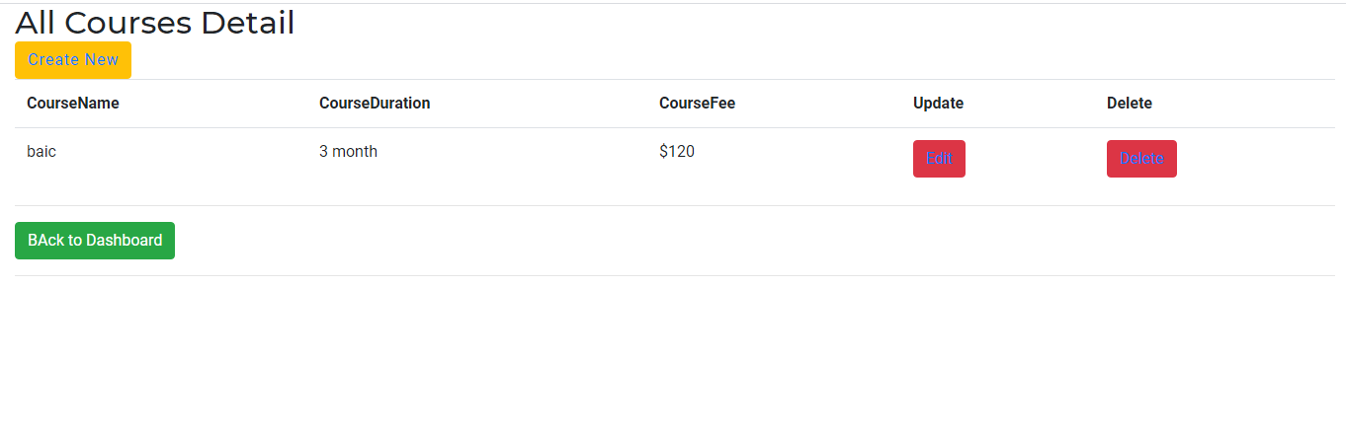

**Add Student**

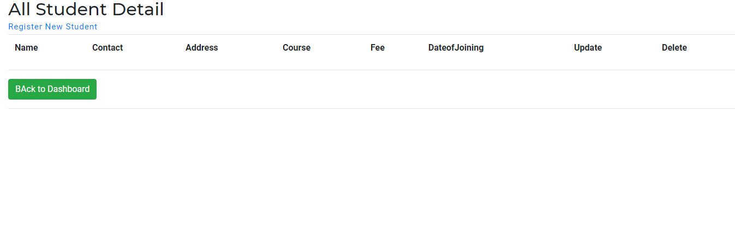

**Register New Staff**

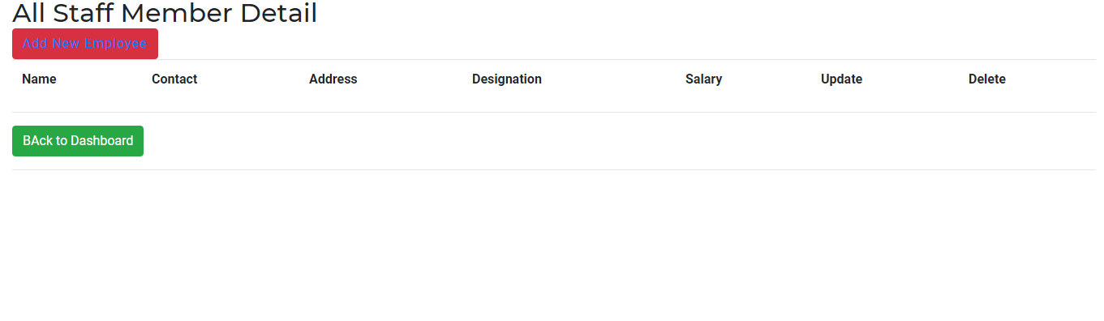

**Fee Payment**

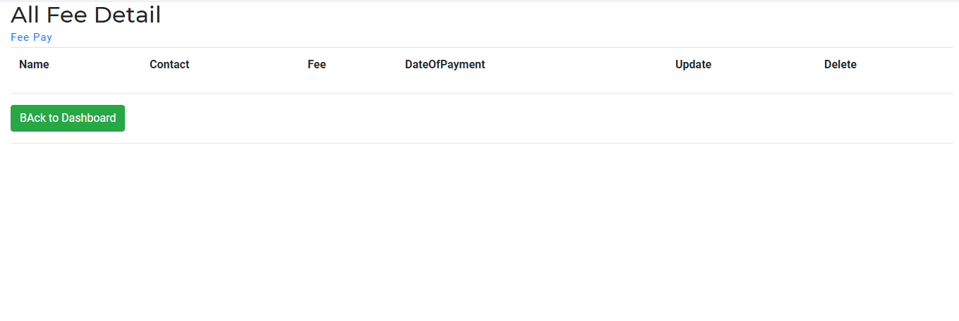

**Contact Page**

Data will be added on front of Contact Page so that anyone contact

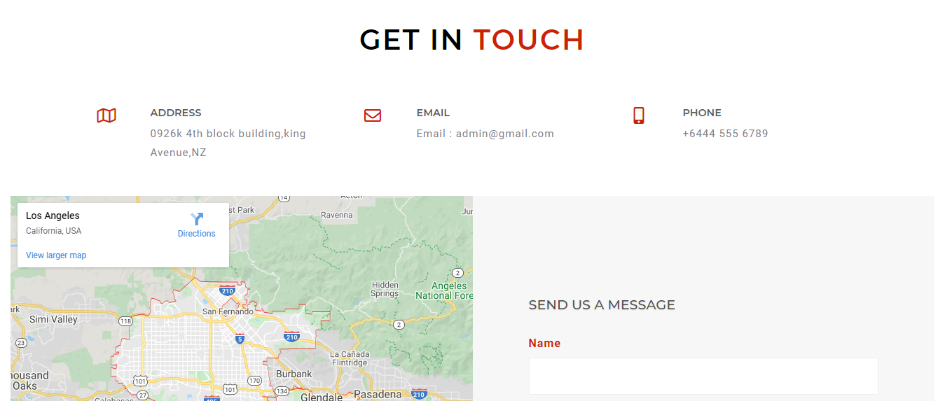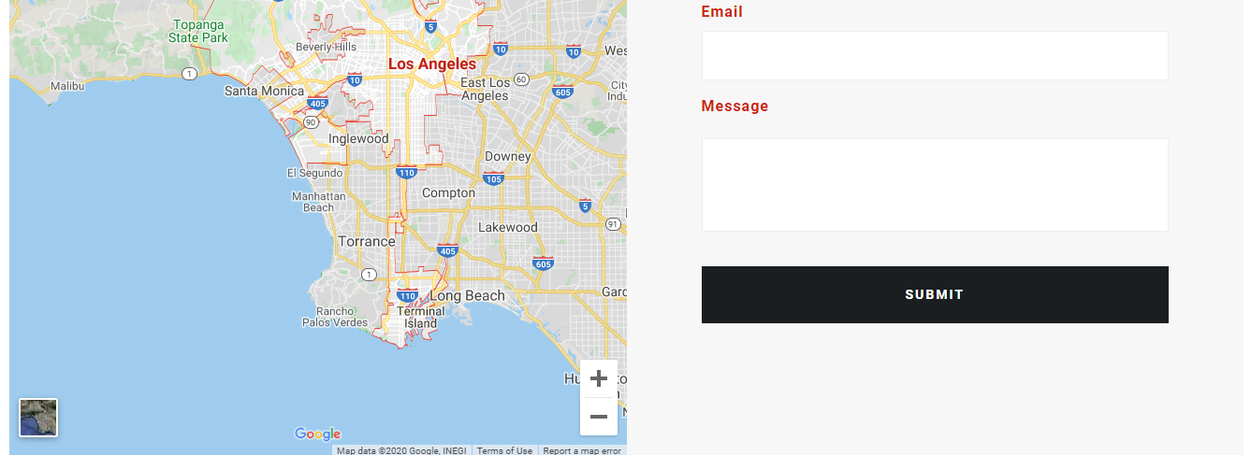

Admin can View Who has Contacted

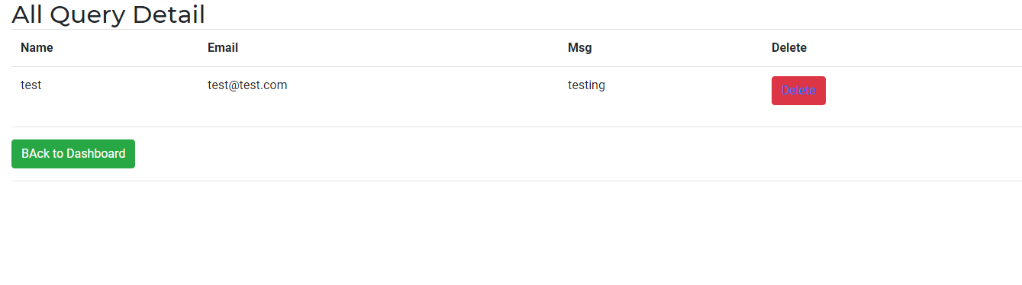

**Here admin delete the viewed messages**

Index Page

WELCOME TO SUNSHINE INSTITUTE

Provide opportunity to B-Tech/B.E, MCA, BCA, Diploma students to enhance their skills and getting practical knowledge through Software and Industrial Training. The company has strong placement cell that assists students to place in various corporate after successful completion of the training. Shineway Software Solution provide training solution nearly for every engineering branch.

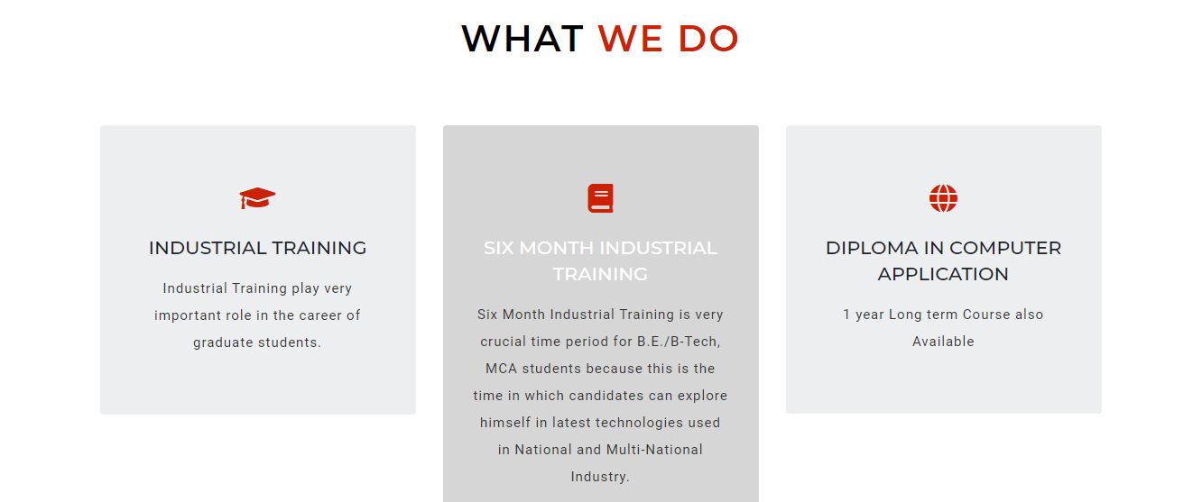

About Us

Welcome Sunshine Institute

We are delivering best and excelent education service arocess the area with lot of experience and knowledge.

Make a good research of our institute and know why we are better that others and start studing here



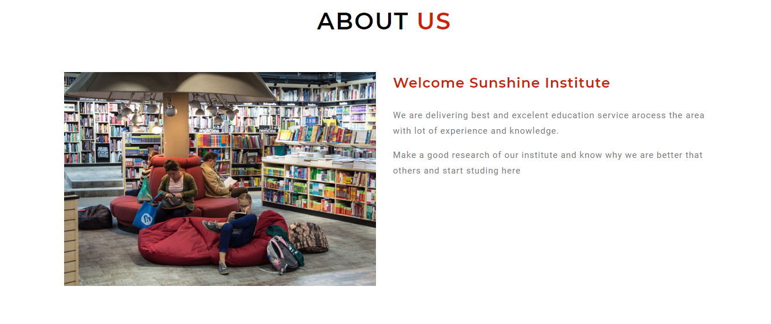

Gallery

